2019

SOFTWARE REQUIREMENTS DOCUMENTATION FOR MOBILE APP

Christabel Acquaye

DEPARTMENT OF COMPUTER ENGINEERING | KWAME NKRUMAH UNIVERSITY OF SCIENCE AND TECHNOLOGY

1. INTRODUCTION

The Electronic Toll Application idea was presented as an addition to the automation of toll collection electronically after an extensive research on the current services offered to most Ghanaians at toll gates. In the research, it was discovered that there were some issues which made the whole collection of tolls quite unpleasant for users due to the wait in the queue. Additionally, it was realized there was no proper mechanism in place to ensure accountability. Due to these issues, toll collection is not really serving the purpose for which it was instituted in the first place.

In this documentation, we describe the software requirements for a yet unnamed application further referred to as the eToll app, its scope and any other relevant information associated in the development of this application.

1.1 PROJECT SCOPE

eToll is to be understood as a middle man application that stands between the user and the toll collection agencies in Ghana. The aim is to prevent representatives of these toll collection agencies from embezzling funds by printing their own receipts and handing them out at toll gates or simply not handing out receipts at all after a transaction has been completed. Thus making these agencies more accountable to the government.

1.2 PRODUCT SCOPE

eToll is designed to provide support for not only the toll collection agencies but also the road users who patronize these services. The primary benefit of the application is that users who in this case are the drivers will be able to pay their tolls electronically without the need to wait and hand money to an agent at the toll gate. It is import to note the app also provides features which lists all available toll subscriptions plans that the user can sign up for so that tolls will be deducted any time he passes through a toll gate. Additionally, information about these subscriptions including their expiry dates, pricing and so on to make the user’s choice more favorable to their needs and demands.

Not only does it provide these services, it also has a platform which enables interaction between toll collection agencies and the drivers.

1.3 INTENDED AUDIENCE AND DOCUMENT OVERVIEW

The intended audience of this document is our overseeing project supervisor, Dr. Bright Yeboah-Akowuah, the registered toll collection agencies on the road users who are particular interested in the development of this project. The document is meant as a means to further discuss the architecture of the application to shed more light on the project topic which was disclosed during the first semester of the 2018/2019 academic year, at the Autotronics Lab during a presentation. It also serves an ancillary purpose of allowing the group track the intended goals and functionalities of the said application.

1.4 Definitions, ACRONYMS AND ABBREVIATIONS

FAQ: Frequently Asked Questions

API: Application Programming Interface

DB: Database

DBMS: Database Management Systems

OS: Operating System

APP: Application

2. SYSTEM DESCRIPTION

Based on the insights of the qualitative research on user’s needs within this field, the team has developed the concept of paying tolls using electronic means. This system should allow the drivers access to certain information about the different toll subscriptions to allow the driver make a well-informed decision as to which subscription he should go for to pay his tolls.

2.1 PRODUCT PERSPECTIVE

eToll is meant to operate on two independent platforms including a mobile application which runs on the Android OS and an iOS platform and a Web Application hosted on a browser for the administrators to monitor all tolling activities.

2.2 PRODUCT FUNCTIONALITY

The application provides services not only for the toll collection agencies but also the drivers utilizing the application. These services include;

1) Platform for drivers to scout different toll subscriptions available to them so they can make a choice based on their preference ranging from their choice of pricing and expiry dates posted by agencies selling toll subscriptions.

2)Platform for interaction between toll collection agencies and drivers so any issues can be addressed.

3)Feature that allows drivers view their history of tolls paid in the past and their location on the map.

2.3 USERS AND CHARACTERISTICS

The users for this application have been grouped under two main categories: Toll Agencies and users who in this case are the drivers who use these toll gates. The following writeup describes these users

**Toll Agencies:** This category of users are the ones who will be in charge of managing the whole toll collection process. This is to say they will be responsible for first providing the tags to be used in this system. The tags encrypted with a unique code that identifies a particular vehicle will be associated with an account that can be managed from the mobile application by the registered driver. These toll agencies will also be in charge of posting various toll subscriptions on the mobile application so that registered drivers can purchase toll credits that can be automatically deducted from their accounts as and when they use a toll gate. They are also in charge of ensuring that estimated toll amounts for a particular period correlates with the actual calculated amount at the end of the period. They will also be available to assist with any issues that may pop up from the end user side.

The use case diagrams give a summarized version of how the toll agencies will actively interact with the system.

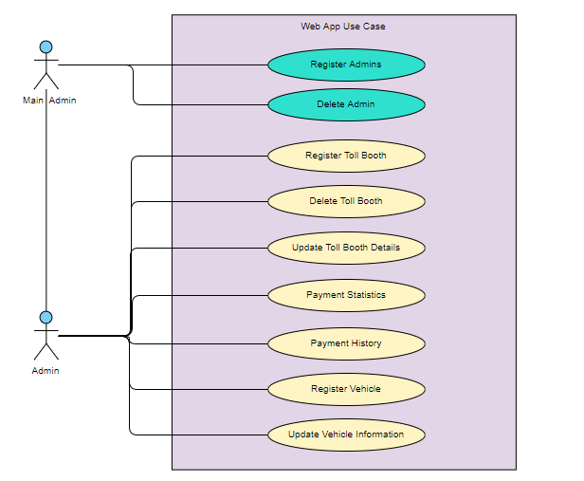

**Drivers (Registered customers) :** These users also benefit from this application, in that they have access to any information they will require about a particular toll subscription posted by an agency. They can even go as far as interacting directly with a representative to ask about issues that may not be clear in the information posted. They then proceed to booking a toll subscription based on information they have gathered. They also get the opportunity of obtaining an e-receipt which provides information about each transaction they make as they use the toll booth. Additionally, they can view past toll information and also view their toll credit balance. They will also be able to receive notifications when a toll transaction is successful.

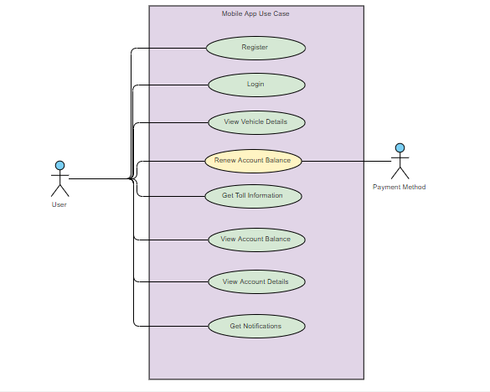

2.4 OPERATING ENVIRONMENT

The clients of this transport management system require a device running Ice Cream Sandwich 4.0 – Kit Kat 4.4 or later for an Android OS and an iPhone with the iOS version of 5. 0 upwards. Additionally, a device with a working Internet with any browser can also be considered.

2.6 USER DOCUMENTATION

User documentation for eToll would be minimal. A FAQ document available on the app would be sufficient to answer any questions users may have through support via email.

2.7 ASSUMPTIONS AND DEPENDENCIES

In this application, we will depend on the PostgreSQL for our database management. In addition, we will use Flask to handle all other backend operations specially the RESTFUL APIs.

2.8 USER INTERFACE



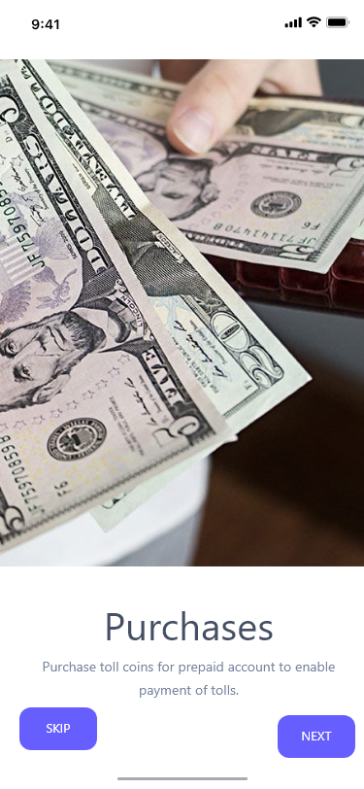

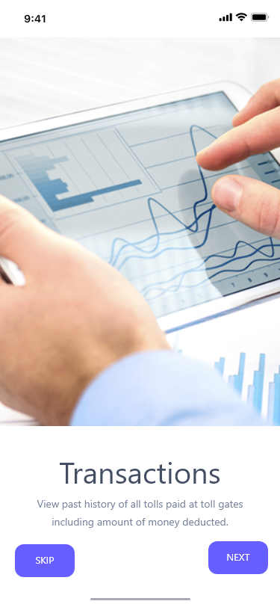 

The above screens basically give the new user some information about the application he /she will be using so they wouldn’t be completely overwhelmed with the environments. As the app basically provides three main function including the purchases, transactions and support feature it is essential to highlight this when the registered driver first uses the application. The purchase slider communicates that the user can make purchase of toll credit using any payment platform he considers necessary. The transaction slider communicates that the user can view information concerning his payments made in the past. Lastly the support section highlights the fact that the various toll agencies will be available to assist the users in whatever way they can in relation to using the system. The app starts with these screens after which a sign up and sign in screen will be provided so as to first allow users log in or for new users sign up to use the system. After the details entered by the user has passed the authentication, the user is directed to the home page which contains two menu icons to allow the user access notifications and also to open the side navigation menu.

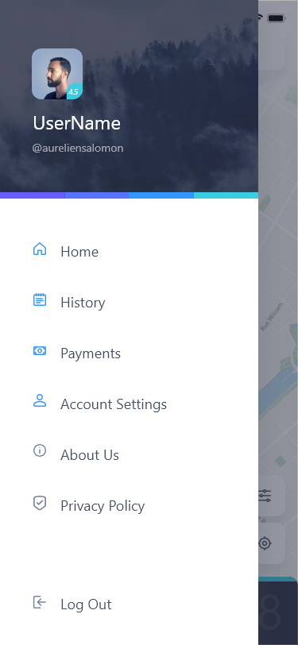

This side navigation provides menu options like the history section, where the user can view his past transcations if any to allow him/her monitior his/her transactions. Information such as the location of the toll gate is provided in the form of a map, in addition the name of the toll gate as known to the system is provided. The amount paid is also presented as well as the date and time the transaction took place.

The second menu option dubbed ‘payments’ presents the user with an interface where he can view his remaining toll balance for a particular subscription he has made. This is to help him monitor his toll credits so that he can make new subscriptions as when he feels it is necessary. Additionally, the payment option screen will also present the user with different subscriptions that has been posted by the various toll agencies so that based on the price and duration presented he can make a decision as to which subscription to choose. Selecting a particular subscription redirects the user to another page where he will select the payment option he prefers and make payments for the toll credit.

The next menu option ‘Account Settings’ will provide the user with the interface displayed below.

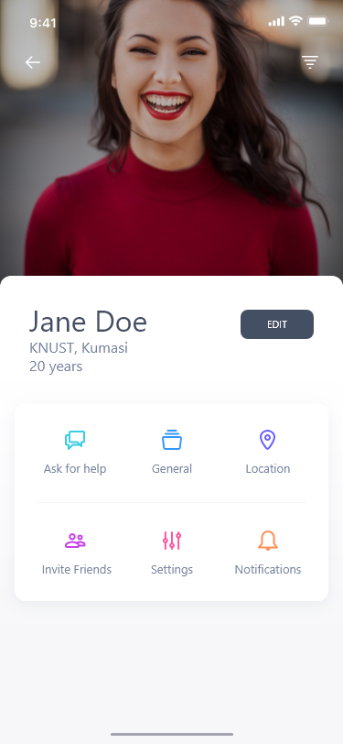

This menu options allows has menu icons which directs the user to

1. Invite a friend to use the system or application.

2. Interact with a representative from the toll agencies to assist him as and when he has issues.

3. Notifications menu where he can click to be directed to a page where he can view all notifications sent to him. Notifications may come in different forms in that he may receive notifications when he makes a purchase or when a transaction has been made.

4. General settings allow the user to make changes to the physical appearance of the app so that he can make changes to the size of the text among other functionalities that will make him have a more custom environment space to work with.

The remaining menu options provide information about the terms, conditions that must be heeded in addition to the privacy policy of eToll.